# $ K + Introduction
The JobAdmin provides for maintaining the Jobs Database. The Jobs File Database is a Microsoft Access 7 database. The Jobs Database can be manipulated using Access.
It is assumed that the user of this program is familiar with Microsoft Windows 95 terminology.

# $ K + Startup
On the desktop or under the Start menu open the JobAdmin icon to start the JobAdmin program. The splash screen will be displayed as JobAdmin initializes. During initialization the open file common dialog is displayed asking for a Jobs Database. Choose a Jobs Database and click open. The Jobs database supplied with JobAdmin and Labeler is named “Jobs.mdb”. The name of the Jobs database and its location can be anylegal name and path. When JobAdmin is initialized the main screen will be displayed.
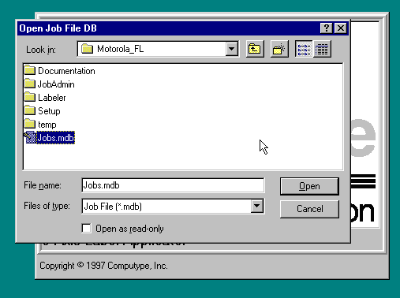

# $ K + Common
This tab dialog contains information that defines the data necessary to uniquely define the Labeler program for this project.
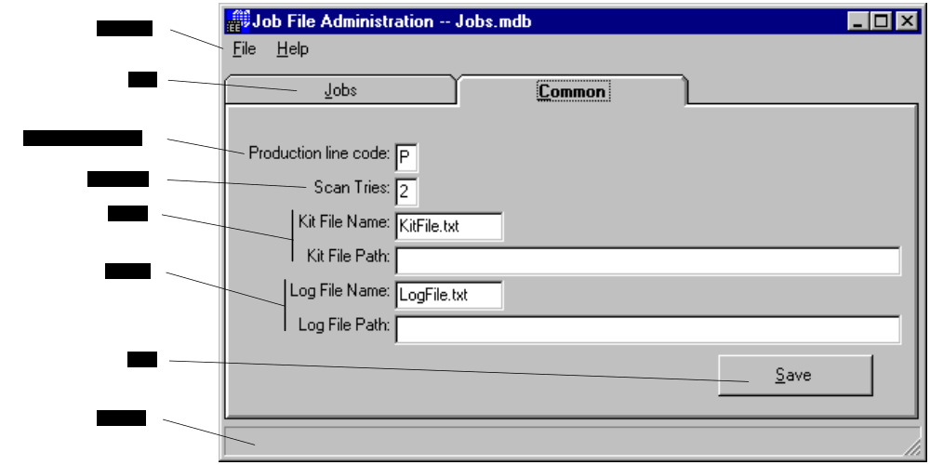
File Menu
Use to open another Jobs Database and exit the program. See File Menu below.
Jobs
Click this tab to display the Job dialog.
Production line code
A user defined one character field indicating the production line for machine.
Scan Tries
Number of times Labeler will scan the label before it reports a bad scan.
Kit File
In the Auto Run mode the kit files cause Labeler to change jobs with out operator intervention. See Special Requirements above for format and description of operation.
Example:
Name | New.kit
Path | C:\Jobs\KitFile
Log File
This file is used to log exceptions and other pertinent events that occur while labeler is running. If the name given is of an existing log file then the existing file is appended to. If no path is given then the labeler EXE path is used.
Example:
Name | Test.log
Path | C:\LogFiles\Test
Save
Saves any change to the jobs database
Help line
This part of the form displays a short description of each field as the mouse is passes over it.

# $ K + Jobs
This dialog provides for adding, editing, and deleting jobs in the Jobs File Database.
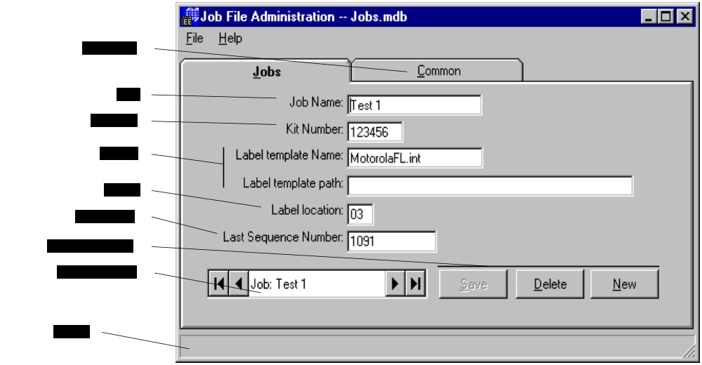
Common Tab
Check this tab to display the common dialog.
Name
Fill in this field with a user-defined name for this job. The job name must be unique for all jobs. The job open form in labeler sorts the jobs using this name. It is also used by the kit processing software to look up a kit file in the jobs database. This must be unique for each job. This field can be the same as the kit number.
Kit Number
Fill in this field with the kit number for this job. This field is used as part of the bar code
Label Template
Fill in these fields with the printer template name and path. The template name is the full name (including the extension) of the file used to build the template. The template path is the full path including the drive letter where the template is located.
Example:
Name | Defalut.sig
Path | C:\Jobs\Templates
Location
A number from 01 to 97 referencing the location number to use when placing the label. Using the teaching pendent or the SA program to set this location in MM from the home position. The home location is the end furthest from the printer.
Serial Number
Last serial number printed for this job. Updated after each label is printed.
Database Functions
Use these buttons to save the current changes, delete the current job and add a new job.
Job file navigator
Use this button to navigate through the Jobs Database.
Help line
This part of the form displays a short description of each field as the mouse is passes over it.

# $ K + File Menu
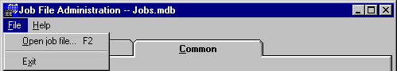
Open job file
Displays the open file common dialog to open another Jobs Database.
Exit
Used to exit the program.

# Introduction
$ Introduction
K Introduction
+ JOBADMIN:0
# Startup
$ Startup
K Startup
+ JOBADMIN:0
# Common
$ Common
K Common
+ JOBADMIN:0
# Jobs
$ Jobs
K Jobs
+ JOBADMIN:0
# File_Menu
$ File Menu
K File Menu
+ JOBADMIN:0

